API Data Integration & AI Ready Pipeline Project

Methods
The following platforms and sites were chosen to analyze 10 specific individuals for this project. The platforms used include:
- Wikipedia
- YouTube
- Twitter/X
- Instagram
- TikTok
- Google Search
The following 10 individuals were chosen for this project:
- Lando Norris
- Stephen Curry
- Cristiano Ronaldo
- Charles Leclerc
- Giannis Antetokounmpo
- Lemelo Ball
- Taylor Swift
- Billie Eilish
- Logan Paul
- Mr Beast

Wikipedia
To extract information from Wikipedia, the official Wikidata API was used. The Wikidata API can extract personal information such as date of birth, citizenship, and other biographical details. It can also retrieve text from different sections of a person’s Wikipedia page. For this project, only the person’s basic personal information and the first sentence of the page summary were extracted. Other section headings were not used because the headings and structure of each person’s Wikipedia page vary.
To extract the data, the Requests library was used to call the API. However, the initial API call only returned the property ID (e.g., P569 for date of birth) rather than the actual value. As a result, an additional API call was required to retrieve the corresponding value associated with that property. The Wikipedia API was accessed without an API key because it is publicly available. The results were then compiled and loaded into a dataframe

YouTube
The YouTube Data API v3, available through the Google Cloud Console, provides data on both channels and their videos. It can retrieve metrics such as subscriber count and the number of video uploads, as well as video-specific information such as total views, likes, and duration.
To extract YouTube data, the Requests library was used along with an API Key provided by the Google Cloud Platform. The retrieved data is further processed as required data is split between the ‘snippet’ and ‘statistics’ part parameters. For this project, only the channel information was retrieved and processed into a dataframe.

Twitter/X
The Twitter API, available through the Twitter Developer Platform, provides data on both user accounts and their posts. It can retrieve metrics such as follower count, following count, and total number of posts, as well as post-specific information such as likes, reposts, and replies.
To access Twitter data, an app must first be registered on the Twitter Developer Platform, which provides a valid API key. This key allows requests to be authenticated when retrieving data from the API. Similar to the previous platforms, the API can be accessed using the Requests library, with most information returned under the ‘data’ parameter. It is worth noting that retrieving data requires the developer account to have sufficient credits. For this project, information from each person’s Twitter account was collected, including follower counts as well as their latest tweets and the associated metrics.

Instagram
Compared with platforms such as Wikipedia and Youtube, Instagram provides limited official API access for public data collection, particularly for personal accounts. Because of these privacy and platform policy restrictions, Instagram data for this project was collected through controlled web scraping of publicly accessible profile pages rather than through an official API. We used Apify as our web scraping method.
The scraping process focused on retrieving profile-level attributes that are consistently visible on public accounts. The primary fields collected included username, display name, biography text, follower count, following count, post count, and profile URL. These attributes provide meaningful indicators of an individual’s online presence and audience reach.
After extraction, the data was processed in Python and standardized into the unified dataset schema used across all platforms. Since scraped outputs often contain formatting inconsistencies, additional preprocessing was required to convert follower and post counts into numeric values, normalized usernames and ensure that profile names matched the canonical person identifiers used in the dataset. Instagram was primarily used for profile-level analysis rather than detailed engagement analysis because deeper engagement data such as likes or comments is not consistently accessible without authenticated API access.

Tiktok
TikTok was included to provide an additional view of the social media presence of the selected public figures. Similar to Instagram, TikTok restricts official API access for public data collection, so the data for this project was gathered using a web scraping approach through a third-party scraping tool.
The scraping process attempted to retrieve publicly visible account information such as username, display name, follower count, following count, number of likes, number of videos, and metadata from the latest video (timestamp, likes, comments, shares, and views).
However, the scraping process was only partially successful, as several fields in the dataset returned None values. This is mainly due to TikTok’s dynamic content loading through JavaScript, platform anti-scraping protections, and limitations of free scraping tools that cannot access internal APIs or authenticated data.
As a result, the TikTok dataset mainly contains profile identifiers and links to recent videos rather than complete engagement statistics. Despite these limitations, the collected data still provides useful cross-platform references for the selected public figures.

Google Knowledge Graph/ Google Search
Google Knowledge Graph and Google Search were used as supplementary information sources to support identity verification and data enrichment. Unlike social media platforms, the purpose of this source was not to collect engagement metrics but to provide structured descriptive information about the selected public figures.
Using Python requests and the Google Knowledge Graph Search API where available, the project retrieved summary descriptions, entity metadata, and reference links associated with each individual. This information helped confirm the identity of each public figure, resolve naming ambiguities across platforms, and identify official websites or verified social media profiles.
Because Google search results are aggregated from multiple sources and may change over time, the extracted information was treated as supporting metadata rather than the primary source of truth. When conflicts occurred between Google results and platform-specific data, the information obtained directly from the platform itself (e.g., Wikipedia or social media profiles) was prioritized. Google data was therefore mainly used for validation, contextual description, and cross-platform linkage within the unified dataset.

Results

Wikipedia:
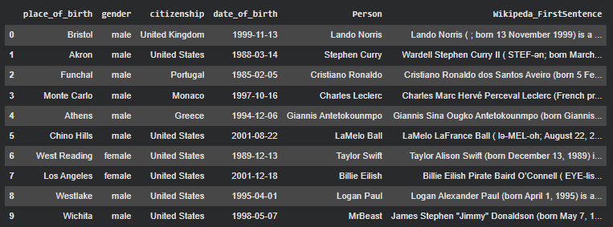

Youtube:
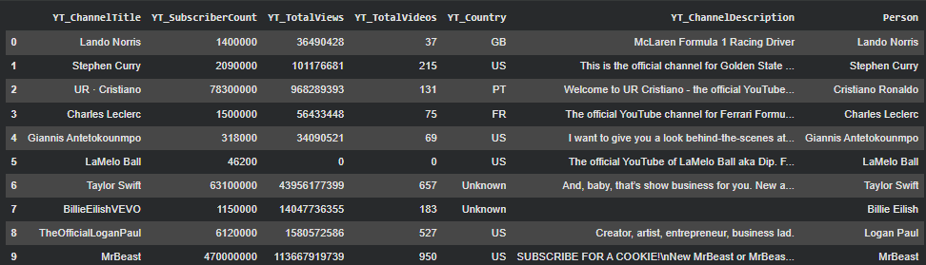

Twitter:
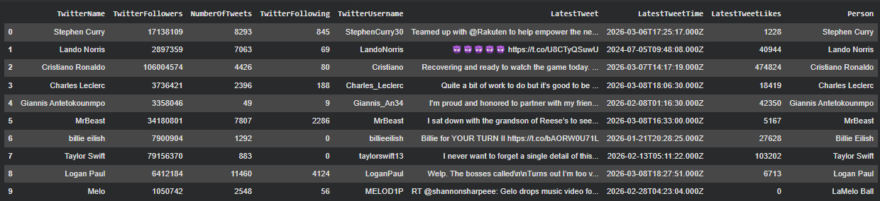

Instagram:
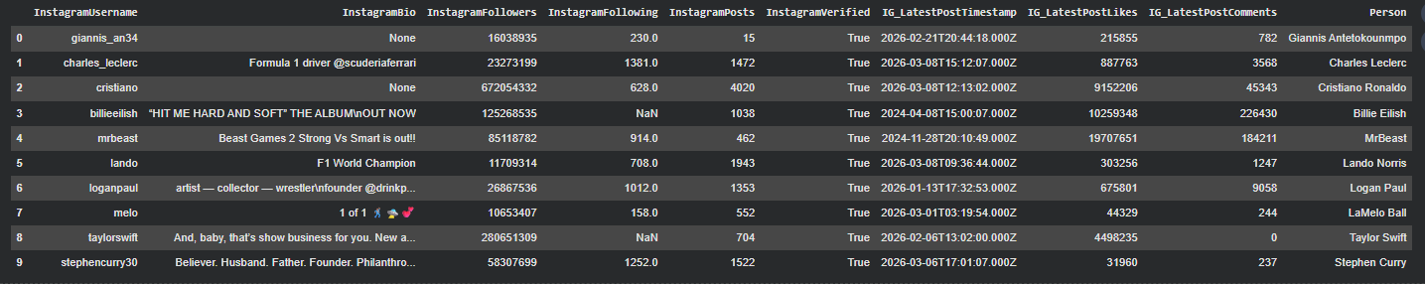
Tiktok:
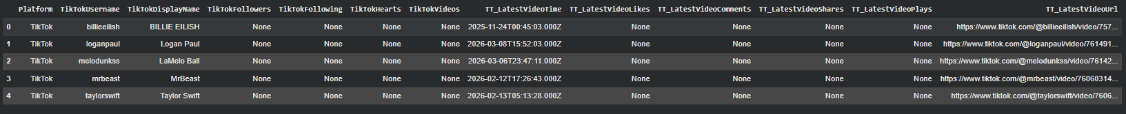
Google Search:
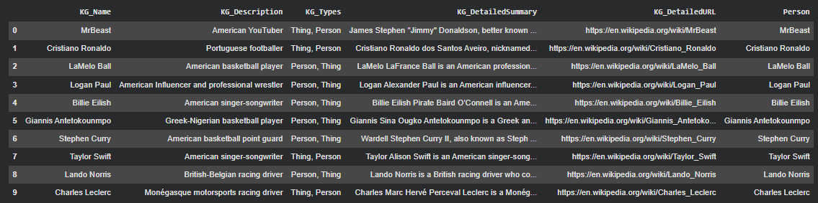
Final Unified Table
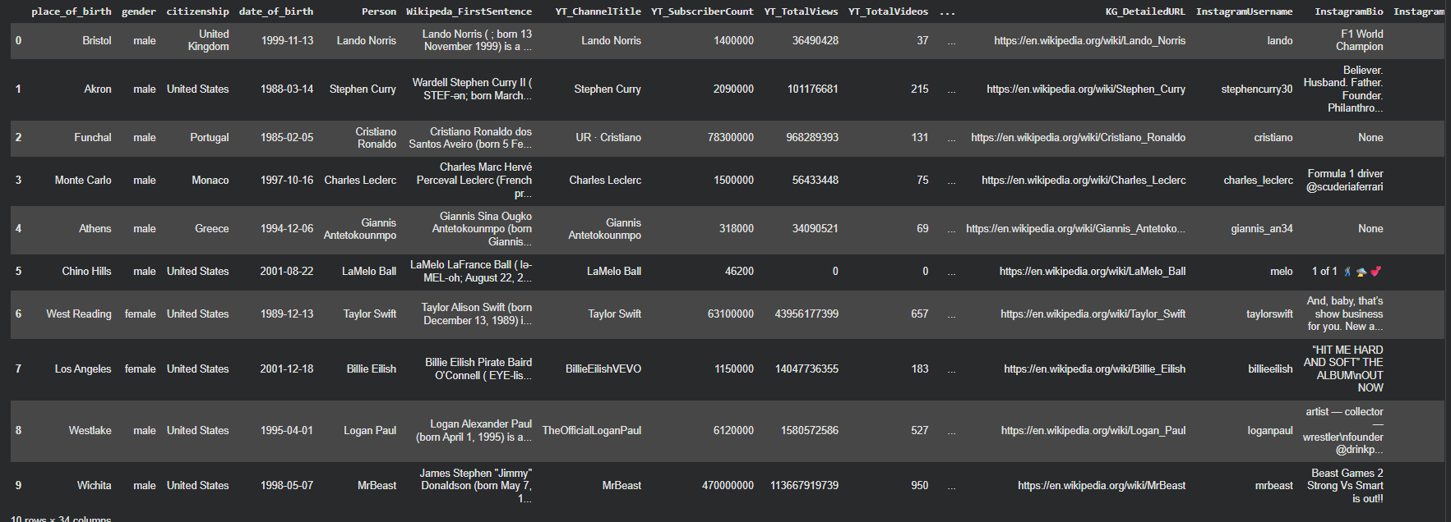
The final unified table combines data from Wikipedia, Twitter/X, Youtube, Instagram, and the Google Knowledge Graph API
Unified Table Columns
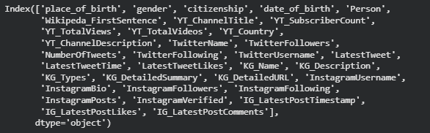

Visuals

Wikipedia
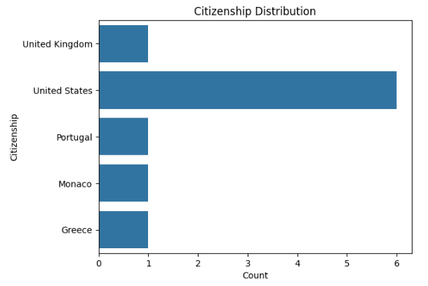
YouTube
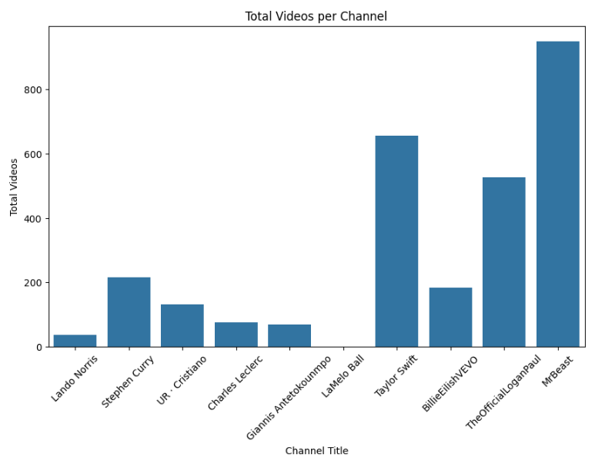
Twitter
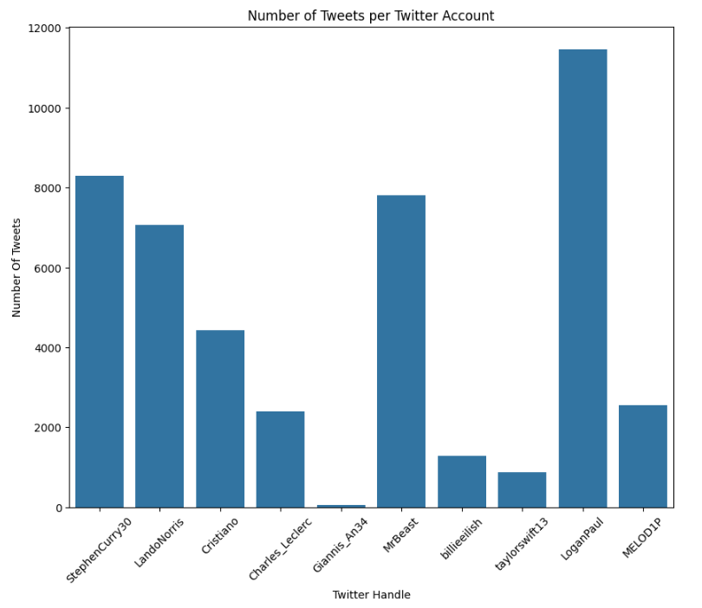
Instagram:
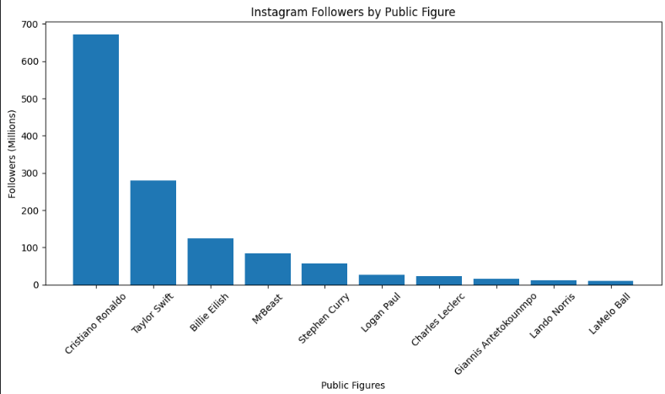
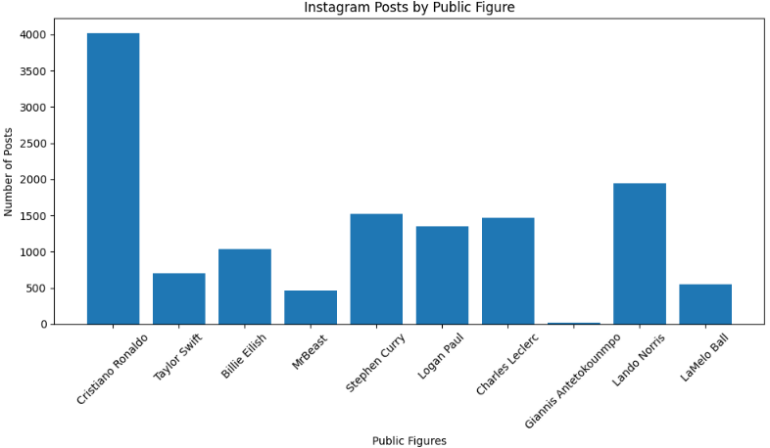

Discussion

APIs make it easier to extract information from social media platforms and websites, allowing public data to be accessed efficiently. However, despite the availability of public information, several restrictions and limitations made obtaining certain data more difficult.

Requests Library
The requests library made it easy and efficient to retrieve data from social media platforms and other websites that provide access to their data through an API. Platforms such as Wikipedia, YouTube, Twitter, and Google’s Knowledge API can be easily accessed using the requests library. Users simply need to provide an API key (if required), identify the correct endpoint, input the correct parameter,and use the library to retrieve the data in JSON format. In some cases, the required data may be distributed across multiple endpoints; however, this can usually be resolved by querying additional endpoints.

APIfy

Limitations
Some APIs did not provide full access to all of their features. In many cases, payment is required to unlock complete functionality. In this project, the Twitter API required credits to be added to the developer account in order to access even basic data. Another API considered for this project was Meta’s Graph API; however, it has several restrictions. For example, it requires a business account, defined use cases, and a connection to a registered application. Even with these requirements fulfilled, access to data remains limited. For instance, developers can only access data from Pages they manage or have created, while data from public Pages would need to be scraped.

A limitation of the dataset is that some TikTok fields contain missing values due to platform restrictions and anti-scraping mechanisms, which limit the amount of publicly accessible profile information that can be retrieved without authenticated API access. The TikTok API, like many other APIs, requires a connected application to retrieve data. However, when accessing data from public pages, permission from the page administrator is often required. When attempting to retrieve data from multiple pages, obtaining these permissions can take considerable time, making the overall data collection process inefficient.

